Cairo University Faculty of Computers and Information



**CS352 – Software Engineering II**

**Software design specification document**

**2018**

**Al italya Lebadat Al Bugs**

|  |  |  |  |
| --- | --- | --- | --- |
| **ID** | **Name** | **Email** | **Mobile** |
| 20150332 | Ahmed Amr Ali Al-Akwah | ahmeditalia122@gmail.com |  |
| 20150365 | Mohamed Fadl Al-Hdrmi | Hdrmim7@gmail.com |  |
| 20150321 | Noura AbdulKarim Mohammed | nouradel975@gmail.com |  |
| 20150331 | Hosam Eldeen Reda Abdulhady | hosamelkashab@yahoo.com |  |
|  |  |  |  |
|  |  |  |  |

**TA:Mohamed Samir**

Contents

Class diagram design 3

Sequence diagram design 5

Github repository link 5

# Class diagram designhttps://scontent-cai1-1.xx.fbcdn.net/v/t1.15752-9/s2048x2048/30710169_1729421147096713_4439324977929388032_n.png?_nc_cat=0&oh=8257b9e702e9c7d6c9dc4b0ab35a8e9e&oe=5B59B5FC

# https://scontent-cai1-1.xx.fbcdn.net/v/t1.15752-9/30738924_1729422867096541_3517117438447583232_n.jpg?_nc_cat=0&oh=da3dd4eef31acd662366b57f37b19962&oe=5B61EB79

# https://scontent-cai1-1.xx.fbcdn.net/v/t1.15752-0/p173x172/30739574_1729423767096451_4173052785287233536_n.jpg?_nc_cat=0&oh=5fbf34fe3775b5a095fd91ba32a68255&oe=5B5695A3

# Sequence diagram design:Buy product.

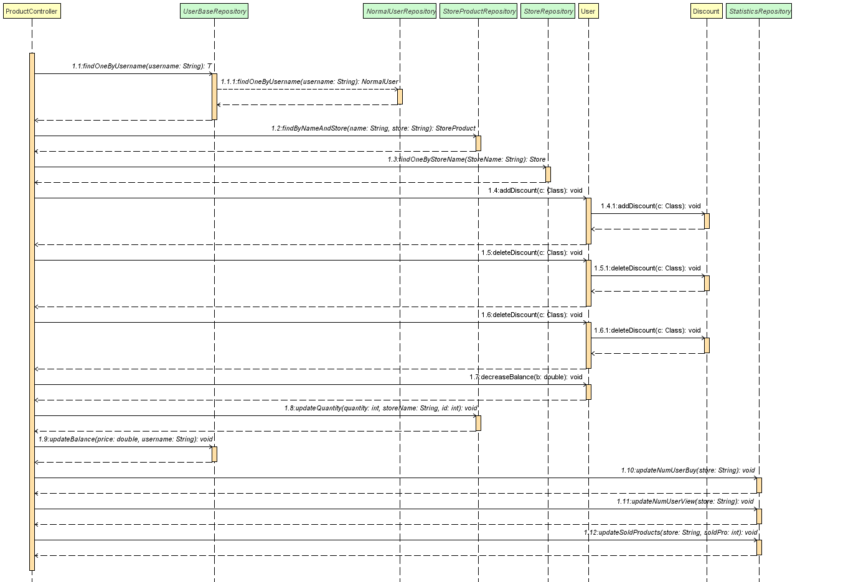

# Github repository link

**https://github.com/ahmeditalia/SWE2.git**